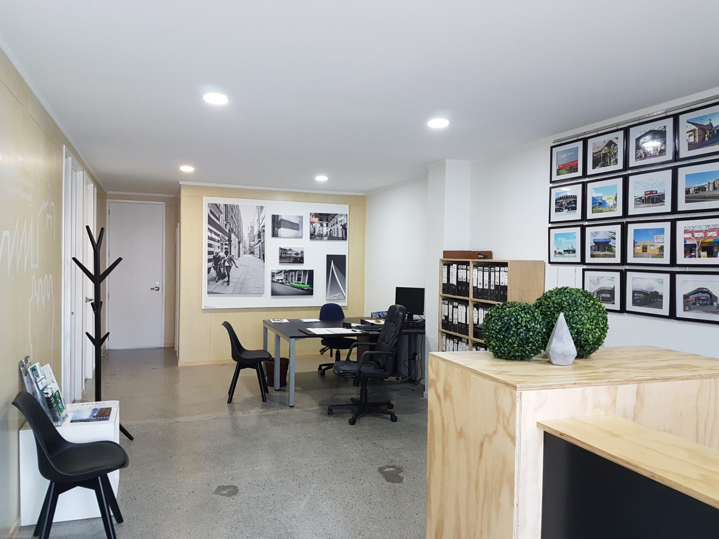

Need a CBD office?

Do you need a stylish office space?
Look no further – enquire within
Cost-effective office space available for small business/SME.
No long-term commitment required.
One office available to share with one other, approx. 3x3m located within larger area occupied by our property investment and management business.
Located in Tauranga CBD.
Meeting room access and other normal facilities.
Monthly rental of $685+GST
Included in base cost for these tenancies a table (if required), meeting room access on as-available basis, wifi, kitchen and associated facilities. Photocopier is available on pay-for-use basis.
Carpark at an additional cost on-site may be available.
This style of office is highly sought after, with a combination of polished concrete floors and combination ply and crisp white interior walls.
Flexible terms, minimum 3 months.
Please enquire within or contact Frances de Vantier on 027 235 3995
or email admin@guideline.co.nz

